2014
TAWREF

ANNUAL REPORT

[tawref annual narrative report 2014]
This is the 4th Narrative Annual Report for TAWREF. It covers the plans and achievements made in strategic areas falling under different programmes. Challenges experienced have also been included. There is a specific column for the way forward for each programme which also forms the basis for the interventions of the following year. TAWREF thanks all development stakeholders who provided support towards the realization of the 2014 plans.

List of Abbreviations
ACE Action for Community and Environment
AIDS Acquired Immunodeficiency Syndrome
APIMONDIA
CCON Child Care Organizations Network
CHAT Coping and Health in Tanzania
CiC Children in Crossfire
CSW Commission for the Status of Women
CSWD Chole Society for Women and Development
DIAC Dodoma Inter African Committee
EASUN East Africa Support Unit for NGOs
ECD Early Childhood Development
ECD Early Childhood Development
FBOs Faith Based organizations
FGM Female Genital Mutilation
FOKUS Forum for Women and Development
FTP Fokus Tanzania Programme
GBV Gender Based Violence
HIV Human Immunodeficiency Virus
IPV Intimate Partner Violence
KCMC Kilimanjaro Christian Medical College
KE Kenya
KWIECO Kilimanjaro Women Information Exchange and Consultancy
LGA Local Government Authority
MSTCDC Training Centre for Development Cooperation
NIMR National Institute of Medical Research
OAC Orphans and Abandoned Children
OVC Orphans and Vulnerable Children
PLwD People Living with Disability
POO Positive Outcomes For Orphans
RBM Results Based Management
SASA Start Awareness Support Action
SIAC Singida Inter African Committee
SNA Social Network Activities
SRHR Sexual and Reproductive Health Rights
TAWREF Tanzania Women Research Foundation
TECDEN Tanzania Early Childhood Development Network
TF CBT Trauma Focused Cognitive Behavioural Therapy
TGNP Tanzania Gender Networking Programme
TtYB Talk to your Baby
US United States
WFN Women’s Front of Norway
WLHIV Women Living with HIV.
WPC Women’s Promotion Centre
ZUMM Zungumza na Mtoto Mchanga (Kiswahili acronym for Talk to your Baby)

Contents
1.0 The Executive Summary 5
2.0 A Detailed presentation of TAWREF’s achievements for 2014. 8
2.1 PROGRAMME 1: CONDUCTING RESEARCH IN THE COMMUNITY 8
2.2 PROGRAMME 2: COMMUNITY CAPACITY BUILDING 12
2.3 PROGRAMME 3: COALITION BUILDING FOR INCREASED COVERAGE AND IMPACT: 17
2.4 PROGRAMME 4: INSTITUTIONAL CAPACITY BUILDING 22
2.5. PROGRAMME 5: ENHANCED EFFICIENCY AND EFFECTIVENESS OF THE ORGANIZATION 23
3.0 Conclusion: Plans for 2015 26
Appendices 29
Appendix No.1: Publications 29
Appendix 2: Some pictures of the Selected 2014 Events 30

1.0 The Executive Summary
The year 2014 was the climax of TAWREF’s 3 year Strategic Plan Implementation. The main focus was based on addressing the Strategic Issues which formed the Strategic Plan itself especially those which were still pending.
The Planned Results for 2014 were:
- Characteristics of 240 OVCs living in institutions and 240 in community (total 480) identified, analysed and documented as input into policy and practice. (POFO)
- Trauma experiences of 128 OVCs have been screened, recorded and followed up for changes.
- 520 marginalized children and families have improved their wellbeing by having some of their strategic needs; social, physical and psychosocial, addressed 50 OVC for shelter, 50 for school sponsorship, 300 for ECD (ZUMM), 50 for revolving projects, 128 for Trauma Focused Cognitive Behavioural Therapy.
- Alliances and Partnerships with 2 other like-minded agencies in and outside the country per year.
- TAWREF’s Resource base expanded by 10% annually towards increased sustainability.
- Benchmarking and Performance Monitoring done weekly, monthly (12), quarterly, (4) bi annually (2) and annually (1) for enhanced efficiency and effectiveness of the organization.

TAWREF went on with the Development Approach of baseline data collection followed by intervention, collaborating with grassroots women’s groups; Faith based organizations and Local government Authorities. Also prioritized was ongoing Skills Development for staff and beneficiaries, Networking and Partnership Building. Anticipated changes are expected at personal level, family, organizational and community levels.
The main achievements based on continued research in the community include the fact that interviewing processes for TAWREF’s longitudinal Studies have continued to add Knowledge, new Attitudes and new Practices regarding the way caregivers in the community and those based in the institutions relate, handle and interact with orphaned children. Research has generated more information to be used to lobby for improved policies regarding orphans care.
There has also been increased gender equity, self esteem and wellbeing for marginalized communities through addressing strategic needs for the orphans, the disabled and the elderly. This was achieved through addressing their rights to access decent homes, right to access education, right to access minimum income, right to psychosocial wellbeing though a Cognitive Behavioural Therapy Intervention, early language stimulation and the right to exclusion barriers and environmental challenges affecting people living with disability. Changes were observed at personal level, Family /Organizational level and community level.
Moreover, there has been growing self esteem for surviving parents/caregivers and their children and or the disabled and the elderly reduced common infections caused by poor living environment; reduced stress; reduced risks of being invaded by animals and creeping objects, reduced risks of juvenile crimes as the children try to run away from dilapidated shelters, reduced early marriages, and early pregnancies and or prostitution/, human trafficking etc. We have also received reports on improved children’s school performance and; Positive Living for People Living with Disability; all being key to realization of socio economic development potential.
Increased household income, positive living, self dignity and access to basic needs for 15 beneficiaries who received business skills, credit and revolving loans. Follow up was made of livelihood projects of WLHIV in Hai and Siha and the projects that were doing well we thos of chicken, piggery, goats and farming. Businesses were facing a problem of market.
Furthermore, there was improved interaction with communities adding to increased acceptability of TAWREF evidenced by partnership strengthening. This was with research partners, research ethical clearance institutions, the media, joining hands with other key players for partnership advocacy events especially during the formulation of the proposed constitution of the United Republic of Tanzania. Other advocacy issues were around lobbying for the rights of people living with disability through a community theatre, tracking gender Based Violence Cases and associated advocacy on the policy makers to take more responsibility for allocating resources on policies related to Sexual and Reproductive Health Rights (SRHR).
During the year 2014, TAWREF consultants got assignments to work with 3 organizations which are partners of FOKUS in the areas of Results Based Management, Appreciative Inquiry, Participatory Monitoring and Evaluation, Report Writing, Fundraising and Baseline Study.
2 publications of TAWREF’s research work were reflected through the Coping and Health in Tanzania Study which ended in 2013 in “AIDS Care: Psychological and Socio-medical Aspects of AIDS/HIV “and in “PLoS One”. The 3 baseline Studies by TAWREF completed in 2014 were presented as Unpublished. In a small way, TAWREF contributed to the realization of the Millennium Development Goals numbers 1, 2, 3 and 6.
TAWREF’s Weekly, Monthly, Quarterly, Biannual and Annual meetings were held at different levels. Institutional capacity development was enhanced by the scheduled staff development meetings with specific capacity development in the Results Based Management and Strategic Planning.

There were a few challenges including:
  - Inadequacies in the Shelter project: Different construction standards used by builders. Most houses not taken good care of/maintenance. Lack of toilets.
  - POFO Research fatigue. Can only reach a certain number of orphans for TF CBT.
  - Meeting the abject poverty in the community as a small CSO compared with the government.
Plan for 2015:
  - Continue with ongoing research: POFO, TF-CBT and Talk to Your Baby
  - Construct 15 houses for homeless children.
  - Embark on a New Strategic Plan for TAWREF which is less ambitious
  - Work on agro ecology activities with one pilot village.
  - Strengthen revolving projects and kitchen gardens.
The TAWREF Board appreciates the Development Partners from different parts of the world who contributed to the 2014 achievements. These include: Duke University’s Centre for Health Policy and Inequalities Research and Duke Global Health Institute, Forum for Women and Development (FOKUS), Vine Trust, Women’s Front of Norway, Children in Crossfire, Christ the Servant Church, Norwegian Farmers and Small holders Union, Episcopal Church as well as friends of TAWREF; Susan Bhaumik and Malfrid Utne.
The TAWREF slogan continues, “Together we can move the mountain , one stone at a time”.

2.0 A Detailed presentation of TAWREF’s achievements for 2014.

2.1 PROGRAMME 1: CONDUCTING RESEARCH IN THE COMMUNITY
Planned  Result | Actual |  |  |  | Intermediary Results/Outcome |  |  |  |  | Challenges |  | Way Forward
1. Conducting Positive Outcomes for Orphans and Abandoned Children Study supported by Duke University.
Characteristics of 240 OVCs living in institutions and 240 in community (total 480) identified, analysed and documented as input into policy and practice.  Planned: R.10= 449  - For Social network Activities (SNA) = 286  Data Entry Plan = 402 and  SNA = 402 planned | -402 (90%) Round 10 Interviews conducted for Positive Outcomes for Orphans (48 F and 77 M in institutions; 125 F and 152 M in community).  -SNA reached = 286 (100%) (48M and 27F in institutions) and (121M and 90 F) in community.  Data Entry: reached: 396 (99%) Questionnaires put on Data Entry for R. 10 and 389 for SNA  Scanning:  R.10: 253/402; SNA: 288/405;  Pending from 2013: R.9: 53 and R.8 30. |  |  |  | The regular interviews have made the OAC and their caregivers understand the importance of improving the attitudes towards each other and the Social Network Activities (SNA) questions have helped the children learn about their sexuality. One of them remarked, “I have received education on how to prevent myself from Sexually Transmitted Infections and the research has been an eye opener for me to understand my basic rights including the right to participating in decision making”. |  |  |  |  | Retention and tracking of both the institutional and community children.  Fatigue by some of the institutions |  | -Keep tracing and motivating the respondents.
2. Organizing a Trauma Focused Cognitive Behavioural Therapy Baseline Study supported by Duke and Washington Seattle Universities.
Trauma experiences of 128 OVCs have been screened, recorded and followed up for changes. |  | 128 children and their caregivers were recruited to make a total of 224/320 all children are from Moshi Rural District. |  |  | -More and more children affected by Trauma identified ready for intervention |  |  |  |  | -Community misconception of what research is all about |  | -Organize awareness raising sessions in the community to clarify the difference between research and interventions.
3. Conducting a Talk to your Baby/ZUMM Baseline and Follow up Studies supported by Children in Crossfire.
Talk to your Baby (TTyB) or ZUMM Results of 300 children in main study collected and analysed. |  | -198/300 families reached (66%)  -3visits made for each identified family.  -Data Cleaned  -Questionnaires sent to Dar es Salaam for Data Entry and Analysis |  |  | - Baseline data on number of words spoken to babies within one hour obtained.  -Babies vocabulary capacity at year one determined |  |  |  |  | Accessibility challenges due to poor infrastructure.  -Results were not ready at the end of year. |  | Follow up results from CiC office in Dar. |  | Follow up for Results  -
4. Conducting Baseline Studies for Kivulini Women’s Rights Organization and Women’s Promotion Centre prior to SASA in Magu and Kigoma Urban districts, supported by FOKUS.
A SASA (Start-Awareness- Support- Action) Baseline Study for 800 males and 800 females conducted in 8 wards of Magu and Kigoma Municipal on 800 male and 800 female participants. |  | - 837 males and 793 females total 1,630 (101.9%) reached.  -Baseline information determined.  - 2 wards in Magu and 2 in Kigoma were to be on control and 2 wards in Magu and 2 in Kigoma were to be for intervention. |  |  | - The prevalence of intimate partner violence found in the research communities is in line with the national level in Tanzania. |  |  |  |  | Less response by men in control communities regarding male promiscuity. |  | Plan for end line study in 2016 to be able to measure the effectiveness of the SASA intervention (2014-2016)  - Make comparisons of outcomes with the control group to measure effect of intervention.
5. Conducting a Baseline and End line Study on Disability in Moshi Municipality supported by FOKUS
A Disability Baseline Study conducted in 10 wards of Moshi Municipality |  | -Results obtained: Physical Disability = 52; Speech Disability =16; Slow learners- 16, mental illness =11. |  |  | -Baseline study Results determined: Physical disability is leading at 52, Speech: 16, slow learners; 16 mental illness: 11, Deaf 1, Deformation:1, Aging: 3, Drug addicts ;1.  - Employment Status: 4% employed; 14% self employed, 30.3% students, 5% retired, 47% unemployed.  -Majority who are under 18 are not attending school.  -Little awareness on services availability. |  |  |  |  | (i) End line study showed school age PLwD still experience difficulties in accessing education services at different all levels.  ii) Majority of the PLwD do not access the required strategic services and facilities |  | -Conduct Advocacy sessions at household level to sensitize family members to prioritize the needs of PLwD.  -Mobilize resources to provide support to young people living with disability.
6. Conducting a Baseline Study and Impact Evaluation of the shelter project supported by a Duke University Student
Needs Assessment and Impact Evaluation of The Vine Trust Project carried out. |  | Baseline study Results obtained for Shelter Support.  7 families have 2 or less meals a day.  - have 3 meals and at least one modern item like cell phone, radio, and bicycle.  -6 have no toilets, 5 toilets were in progress, 3 were temporary and only 1 had a toilet. |  |  | -11/15 households reported having a peace of mind.  -4/15 reported improvement on their economic status as they spent the little money they had to meet other basic needs.  -14/15 households added flowerbeds and trees around their houses.  - Beneficiaries are now conducting businesses: Shop; 7, Farming: 2, selling water; 2, poultry – 3,Milling machine; 1 |  |  |  |  | Poor response on cost sharing from community and local Government Authorities regarding toilet construction. |  | -Embark on Lobbying and Advocacy to instigate positive community response towards helping the marginalized.

7. Obtaining Relevant Research Ethical Clearance for research study with local, national and International Review Boards.
1.5.1 Research Ethical Clearances obtained from various Institutional Review Boards |  | 4 Research Ethical Clearances obtained from the Duke IRB, the KCMU IRB and from the National Institutes of Medical Research (NIMR), Dar es salaam and Lake Zone. |  |  |  | -Research conducted with required approval  - A few publications were made. See Appendix No.1 |  |  |  | The whole process is Time consuming. |  | Plan for an early start for application of Ethical Clearance.
2.2 PROGRAMME 2: COMMUNITY CAPACITY BUILDING: 520 marginalized children and families have improved their wellbeing by having some of their strategic needs; social, physical and psychosocial, addressed.
1. Constructing houses for homeless orphans and vulnerable children supported by Vine Trust
10 moderate houses constructed for 50 OVC. |  | -20 houses constructed or 200% increase.  -83 OVC (48.M and 35 F) were supported (166 %).  -15 out of 20 (80%) houses were handed over and 5 were pending completion. 1 of the houses was for 3 old men and 2 houses were for beneficiaries living with disability. |  | -Improved Partnership Building in construction of Houses for the homeless.  - Reduced stress and increased peace of mind  -Improved access to basic rights of Orphans and Vulnerable Children  through: reduced infections, reduced risks of being invaded by animals and creeping objects, risks of juvenile crimes, early marriages, early pregnancies, prostitution , human trafficking etc  - Positive Living for People Living with Disability.  - Increased self esteem for surviving parents/caregivers. |  |  |  |  | -Most of these housed do not have proper toilets.  - Slow response from the Local government authorities to support community with Ventilated Improved Pit Latrines |  | - Work more closely with FBOs , LGAs and grassroots in identification of OVCs and cost sharing.  -Form a Housing and Livelihood Committee.
2. Providing Holistic Support to the shelter beneficiaries with the support from the Episcopal Church of North Carolina.
Household income promoted through provision of Credit and Revolving Loans for small projects to 15 Vine Trust beneficiaries |  | Retail shop (3); goat keeping (2)selling water (1)catering (1); poultry (4) selling used clothes(2) selling vegetables (1) selling firewood(1) | - Poor communities supported to access credit.  - Holistic support changed lives of shelter beneficiaries through Revolving Projects  - Increased Access to healthcare.  -Increased gender equity,  -Reduced stigma and discrimination.  -Way to realization of socio economic development potential |  |  |  |  | Follow up Report on progress of projects is pending. |  |  | -Provide refresher training on business skills for sustainability.  -Link the shelter supported households with Community Health Fund for Health Insurance..
3. Providing the right to education to Orphans and Vulnerable Children supported by Susan Bhaumik, and the Episcopal Church of North Carolina
50 OVC supported with school sponsorship  -40 OVC given 1-2 solar lamps for night study as a response to letters to their donor. |  | -74 (148%) were reached:  27 in Secondary School, 10 in Primary School and 5 for Vocational Skills by Susan Bhaumik & 32 Episcopal Church, of North Carolina at Primary School and Secondary School. | - Access to education implies reduced consequences of ignorance and sustainable future. Total (74).  - 2 very needy orphans were recommended for long term sponsorship by the Arusha based organization “The Foundation for Tomorrow” (TFFT). |  |  |  |  | - Some orphans are forced to move from one caregiver to another and they become lost to find. |  |  | -Explore possibilities of giving school sponsored OVC capital for small businesses to develop sustainability.  -Form an OVC Education Support Committee.
4. Conducting Intervention in the community to build community capacity on the importance of Talking to their Babies.
Talk to Your Baby Intervention Sessions organised in the community on 150 families in the intervention community and later 150 families in the control community. |  | - 104 (69.3%) reached on the necessary stimulation for language development to babies.  - 96 (64%) reached in the control community. | -Increased awareness to parents on the importance of talking to babies.  -Actual Results pending. |  |  |  |  | - Lack of accurate information on location of houses  -Families moving out of community  -Lack of reliable transport to reach homes.  -Data entry done in Dar no timely feedback on results. |  |  | - Organize Feedback meetings to both communities.  -Discuss with CiC on how to get timely feedback on the ZUMM reports that are prepared by the head office.  - Make comparisons of outcomes with the control group to measure effect of intervention.
5. Conducting a Disability Mainstreaming at TAWREF and raising community awareness on the rights of PLwD
Disability Mainstreaming has been affected at the TAWREF Workplace and the community has been made aware of the rights of PLwD in 10 wards of Moshi Municipality. |  | Training conducted for 26 TAWREF Staff and Board members and in 10 wards of Moshi Municipality market centres, roadsides on the rights of People Living with Disability using 10 community Theatre Sessions. | -Increased knowledge among TAWREF workplace and beneficiaries in the 10 wards regarding the rights PLwD and the services available.  -Mainstreaming Policy drafted at TAWREF.  Documentation of Baseline and End line Studies. |  |  |  |  | Short lived project |  |  | Design ways of following up the families living with PLwD.
6. Organizing intervention sessions and individual visits for children who are experiencing trauma and their caregivers for the Intervention group only.
Trauma Focused Cognitive Behavioural Therapy applied on 64 out of 128 OVC in Moshi District Council and Moshi Municipality as planned.  -1,264 Questionnaires put on Data Entry |  | 8 group Sessions were organized in which 64 children were put on therapy (50%) and 64 on control.  -1,136 (89.9%) questionnaires were entered on Data Base. | Individual visits between sessions 4,5 and 6 also joint sessions with caregivers, followed by 3 month, 9 month and 15 month follow up all of which helped children reduce triggers, grief and trauma. Some children expressed that they were no longer lonely and sad since they apply the skills learnt which make them think, feel and behave differently.  Reduced trauma reported in some children.  Improved school performance reported in some children. |  |  |  |  | Caregivers and children moving out of community anytime. |  |  | -Collect more change stories from children and caregivers.  - Make comparisons of outcomes with the control group to measure effect of intervention.  - Refer specific cases to the respective committees.
2.7 64 caregivers 32 males and 32 females reached with psychosocial education |  | 64 caregivers reached. | - Reduced stress; Improved relations with children; Revived parental skills. -Increased number of successful referrals to the Standard of Care: 2 were referred to medical care and were treated free of charge (malaria and shoes for the disabled); 1 was linked with the Local Government support for orphans and sponsored for secondary education; 1 was referred for educational sponsorship. 3 were referred to the Vine Trust Shelter support project and had houses built for them. |  |  |  |  | High expectations on TAWREF by caregivers as most of them expect to get economic support. |  |  | - Educate communities on what research is.  - Keep linking caregivers with the Standard of Care facilities.
7. Working with grassroots groups to facilitate them to run business and use profit to help OVC in their areas.
Grassroots groups under TAWREF have supported OVC to adopt of healthy behaviours through rights based interventions. |  | -2 grassroots groups (Mowo and Same) were mobilized for IGA and OVC and PLHIV support with support from Malfrid.  - 2 ICDP groups in Majengo, Msaranga and Njoro were reactivated.  -One group from Njoro participated in the Disability sensitization Community Theatre. | - The Same women grassroots group has helped people Living with HIV with nutritional support and are paying rent for one member who cannot afford business.  -The Mowo grassroots’ group supported 5 OVC studying in primary school with scholastic materials and one orphan studying at a vocational training centre.  -One success story of a young father who did not like his child born outside marriage who was transformed by his ICDP group and he changed attitude.  - Increased awareness on the rights of PLwD. |  |  |  |  | - Businesses face competition.  - Theft of chicken.  -Way forward for ICDP due to lack of funding.  Measurement of community Response for a short lived project. |  |  | - Train Mowo women to engage in Agro forestry for food security and addressing climate change impact and adaptation with the support of Envirocare.  - Train women farmers in organic farming, Green house farming, Health Insurance, Beekeeping &Environmental Conservation  - Work with the Norwegian partners to revive the ICDP intervention.  Use the Community Thetare group whenever opportunity arises
2.3 PROGRAMME 3: COALITION BUILDING FOR INCREASED COVERAGE AND IMPACT: Building synergy with likeminded organizations (TGNP, WPC, SIAC, DIAC, CSWD, KWIECO) to raise community awareness and women’s capacity and assertiveness to demand their rights
- Coordinating a FOKUS Tanzania Programme made up of 6 partners
A FOKUS Tanzania Programme (FTP) is well coordinated to realize the programme results |  | 3 Capacity Building sessions conducted with 2 in Moshi and 1 in Dodoma to 14 participants. | - Gained skills in drafting presenting and tracking women’s demands in the proposed constitution.  -Acquired skills in designing best practices, advocating for regional and national accountability in SRHR, working with media, reduction of GBV and programme exit strategy. |  |  |  |  | -Following up programme sustainability strategy as partners are located in different parts of Tanzania. |  |  | -Work via email and telephone to track progress of good FTP work started.
- Facilitating 2 Women’s Front Partners to improve their interventions on preventing FGM
Women’s Front partners DIAC and SIAC who work on elimination of Female Genital Mutilation (FGM) in Singida and Dodoma have improved their Community Entry Skills |  | -Skills enhancement for DIAC and SIAC 13 staff.  -10 Committee members.  -20 village facilitators in SIAC and 35 in DIAC. | -Improved management approaches by the staff and governance of the DIAC & SIAC committees.  -Improved understanding of the 2015-2019 Results Matrix and Fundraising skills.  -Increased confidence among new village facilitators in Self awareness in their new roles, Data Collection & community entry skills: leading communities to change attitudes, being innovative, communicating versus confronting, listening to community.  -Improved Report Writing skills.  -Displaying; maturity in opening dialogues with various community leaders to demand their accountability with prevention of FGM.  - LGA leaders have started to integrate FGM as an agenda in their meetings. |  |  |  |  | - Some of the local stakeholders do not respond positively to the project: Some teachers hide information for example on girls’ absenteeism when they go for FGM, the local leaders protect perpetuators of FGM and GBV.  -Project is donor dependent and is likely to face a threat in case of donor withdrawal.  - |  |  | -Work more on Local Government Mainstreaming FGM in their District Comprehensive Planning and Ward Development Planning.
- Facilitating 2 FOKUS partners to conduct a Baseline Study on Intimate Partner Violence (IPV) prior to the SASA Intervention in Magu district.
FOKUS partners of Kivulini and Women’s promotion Centre have been supported by TAWREF to collect data for the SASA Start- Awareness-Support-Action)  Baseline Study on “Intimate Partner Violence”. (IPV). |  | Supported Kivulini and Women’s promotion Centre for a Baseline Study based on “Intimate Partner Violence before conducting an intervention on SASA:  Data collected in 4 intervention wards and 4 control wards in Magu - Mwanza and Kigoma Municipality. | -Baseline Information obtained and report produced:  - Prevalence of IPV was found to be in line with the national level.  - Men seemed to have general progressive attitudes to IPV compared to women who seemed to so accept violence as part of their normal lives. |  |  |  |  | - Harsh weather especially in Magu district of Mwanza.  -Misinterpretation of researchers as freemasons. |  |  | -Identify areas with conflicts and or discrepancy and use them as entry points for intervention.  -Organise an End line study in 2016.
- Taking part in network activities with likeminded organizations.
TAWREF has participated in Network events with other key players |  | -TAWREF representatives participated in network events with The Norwegian Farmers and Small holders in Norway for sharing Climate Change initiatives and attending a World Social forum; TECDEN,for Early Childhood interventions experience sharing meetings; CCON for experience sharing on children services ; Project Launch by WPC &Tusonge CED; Participated in the CSW in New York sponsored by FOKUS; Participated in the POFO partners meeting in Istanbul, Turkey: Participated in KWIECO and TGNP meetings to discuss women’s demands in the New Tanzania Constitution discussion at local and national levels; Participating in the first Apimondia for Africa: ”Bees for Development” to get to know the resources available in Kilimanjaro and Tanzania; Participated in Training from MSTCDC for Gender and Tax Justice, EASUN for Learning Based Monitoring and Evaluation; Participating in supervision meetings and visits between TAWREF and ACE of Kenya.  -Worked on a joint proposal development with Envirocare for “Women Tackling Climate Change” | -Increased knowledge and capacity of TAWREF on various issues discusses  -Increased credibility of TAWREF through local, national and international presentations of work done. |  |  |  |  | - Some coalitions are loose with no sustainable strategy. |  |  | Design a TAWREF network strategy
- Building Alliance with the Local Government and Faith Based Organizations.
Strategic Links with the Local Government and Faith Based Organizations |  | -Commemorated Joint Events : World AIDS Day, International Women’s Day, 16 Days of Gender Based Violence; OVC house launching  - Participated in Reports Sharing meetings on HIV and AIDS. | - A few LGA members and FBOs participated in identification of OVC for education, shelter support identification and followed up revolving projects  -Moshi, Hai and the Municipal District Councils made verbal commitments to contribute towards toilet construction. |  |  |  |  | Ward Development Plans not prioritizing the poor and the needy. |  |  | Follow up commitments made by the LGAs.

2.4 PROGRAMME 4: INSTITUTIONAL CAPACITY BUILDING
- Organising ongoing staff and board capacity development at TAWREF.
TAWREF Staff and Board have undergone Capacity Development in various strategic areas |  | 24 staff members trained in Results Based management (RBM).  -23 Staff members trained in Mainstreaming Disability, Strategic Planning.  -Induction Training conducted on 4 new staff members.  - A few staff members were trained through network events as indicated above.  - Human Resource related issues were democratically attended. | -Increased implementation of participatory strategies through: Participatory Design of TAWREF’s Strategic Plan 2014-2019; Participatory Management for Democratic Decision making observed daily, weekly, monthly through staff meetings; A participatory Staff performance appraisal was conducted at the end of year.  - Improved research skills for 4 supervisors, 6 counselors , 2 interviewers and 1 data clerk (CBT)  -Improved staff morale through Creation of sharing space for airing views/concerns/ dissatisfaction.  A new organizational Policy on Disability Mainstreaming was drafted. |  |  |  |  | Staff Turnover |  |  | Conduct staff training on Financial management for Non Financial managers, Learning Based Monitoring and Evaluation& Impact Reporting.
2.5. PROGRAMME 5: ENHANCED EFFICIENCY AND EFFECTIVENESS OF THE ORGANIZATION: Fundraising initiatives and Publicity:
- Writing Grants Applications, expanding the shop and raising money through consultancy
Fundraising:  TAWREF’s Resource base expanded by 10% annually towards increased sustainability |  | - Wrote 4 proposals to different donors (FOKUS, WF, Duke)  - Added more products in the TAWREF Charity Shop.  -Saving 10% of consultancy fees as a fundraiser.  - Worked on a cultural Tourism through a “Positive Travel” initiative | - Raised 733,035,834/22 18% increase over (621,477,583/07) solicited in 2013.  -Part of this (9,086,517/89) was raised by the Charity Shop as profit.  -2,800,000/- was raised through consultancy work.  - Malfrid, a friend of TAWREF provided fund (2,000,000/=) which will be used to launch a TAWREF Building Account and entry point to sustainability. |  |  |  |  | - Inadequate fund solicited for Administrative expense as a strategic area. |  |  | Make this an ongoing endeavour.
- Re hosting of TAWREF’s Website to read” www.Tanzania womensresearchfoundation.org.
The TAWREF Website has been re hosted for easy updating |  | -Supported by some friends of TAWREF, Tom and Mary Zulauf and David Bruckenstein to draft and build it on a “template” based system which is easier to administer and free for TAWREF as a nonprofit.  - Added a few pictures on the TAWREF facebook. | A new easy to update and edit website and free launched |  |  |  |  | - |  |  | Make use of the ne New IT personnel at TAWREF to provide updates.  -Keep updating the TAWREF Face book
3. Hosting office visitors
Office visitors from different parts of the world hosted by TAWREF. |  | -Visited by Her Royal Highness, Princess Ann Patron of Vine Trust in October.  -Received development partners from FOKUS (June), Vine Trust (April-December), CiC (February & October), Women’s Front of Norway (July), Duke University (August), Washington Seattle University (August); The National NGO Coordinating Committee( June);  ICDP, Norway (October). Finally the 1st Lady of Tanzania Ms Salma Kikwete visited our exhibition in April 2014. | -Increased publicity and credibility of TAWREF.  - Enhanced shared understanding of projects outcomes. |  |  |  |  | - |  |  | Start implementing agreed way forward with different partners.
4. Organizing regular Learning Based Monitoring and Evaluation and Impact reporting sessions.
Projects followed up closely to document learning through Participatory Financial and Narrative Monitoring and Evaluation Reports produced at (50) weekly (12) monthly (4) quarterly, (2) bi annually and (1). |  | - Benchmarking, Performance Monitoring and reporting was done  - Made regular entries in quick books to facilitate timely financial accountability.  - Organized shared learning and participatory decisions through management, staff and board meetings.  - A Staff Unfairness barometer was monitored after an Effective management Training in 2013.  - Conducted specific evaluation for the shelter project, SIAC and DIAC projects | - 45 weekly reports; 8 monthly; 3 quarterly; 1 biannual; 1Annual accomplished.  - Timely adjustments and reporting of projects progress.  - Impact assessment results of shelter project obtained.  - The overall results indicated improved fair treatment of staff.  -Evaluation reports are shared separately. |  |  |  |  | - Learning Based Monitoring and Evaluation and Impact reporting not quite understood by some staff members. |  |  | Include LBM&E and Impact Reporting on the Staff Development Programme

3.0 Conclusion: Plans for 2015
TAWREF’ new Strategic Plan (2015 -2019) is more forward looking with an improved focus on research and community services and will integrate some of the Sustainable Development Goals. TAWREF will facilitate village women to embark on Agro ecology activities so as to be active participants in Climate Change Adaptation and Impact Mitigation but also demand community’s commitment in supporting the marginalized. In the year 2014 we could not raise any big fund for construction of our office building and Trauma Training Centre. Plans for 2015 are to solicit funding for this important task for TAWREF’s sustainability. Once more the TAWREF Board cordially appreciates everyone’s contribution that made the year 2014 a success.
“Together we can move the mountain , one stone at a time”.

Dafrosa Kokulingilila Itemba, Executive Director

Appendices

Appendix No.1: Publications
Publications made in 2014
- Belenky N, Cole SR, Pence BW, Itemba D, Maro V, Whetten K. Depressive Symptoms, HIV Medication Adherence, and HIV Clinical Outcomes in Tanzania: A Prospective, Observational Study. PLoS One, In press, 2014.
- Ostermann J, Whetten K, Reddy E, Pence B, Weinhold A, Itemba I, Maro V, Mosille E, Thielman T & The CHAT Research Team. (2014). Treatment retention and care transitions during and after the scale-up of HIV care and treatment in Northern Tanzania. AIDS Care: Psychological and Socio-medical Aspects of AIDS/HIV. doi: 10.1080/09540121.2014.882493
Unpublished
- Impact Evaluation and Needs Assessment for the Vine Trust Project.
- SASA Preventing Violence Against Women and HIV. Baseline Study Results in Tanzania.
- Mainstreaming Disability at TAWREF; Baseline Study Report.
- Mainstreaming Disability at TAWREF; End line Study Report.
- DIAC and SIAC Evaluation Report.

Appendix 2: Some pictures of the Selected 2014 Events
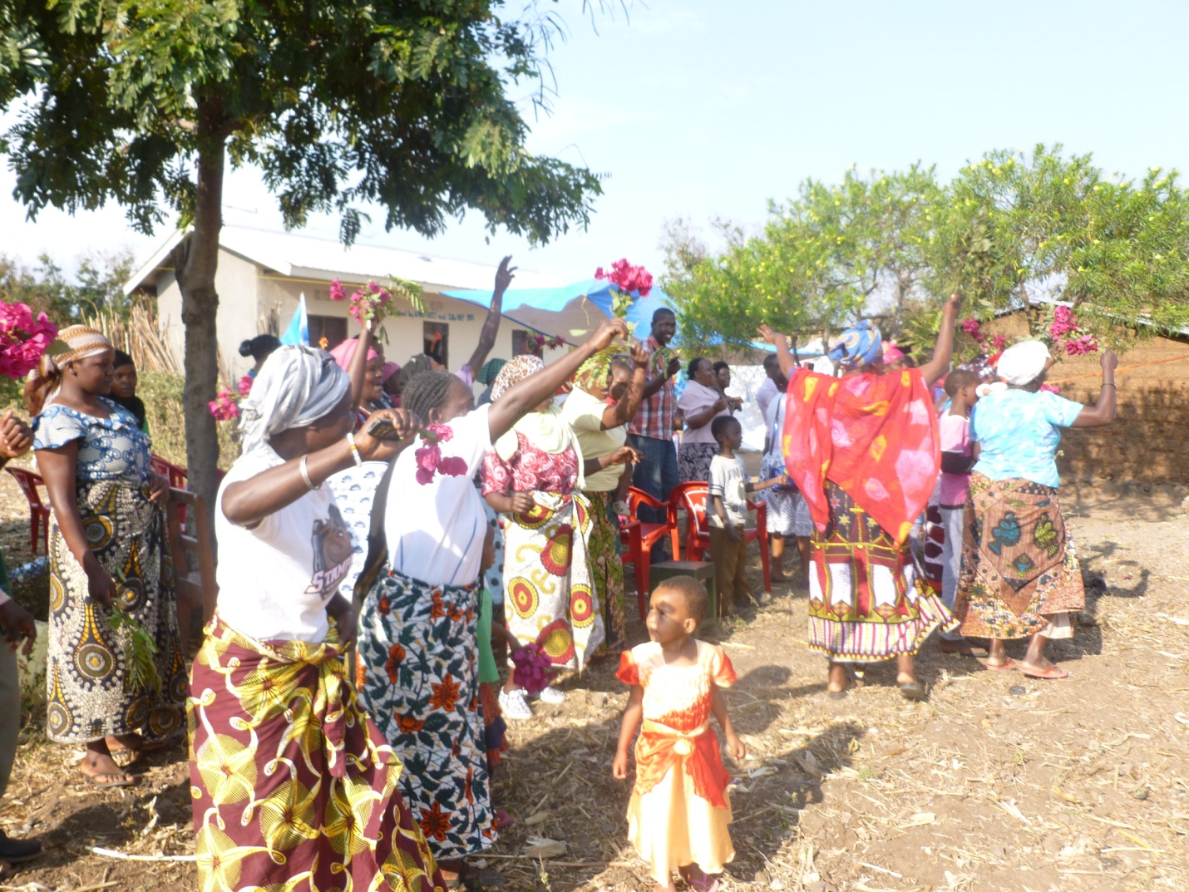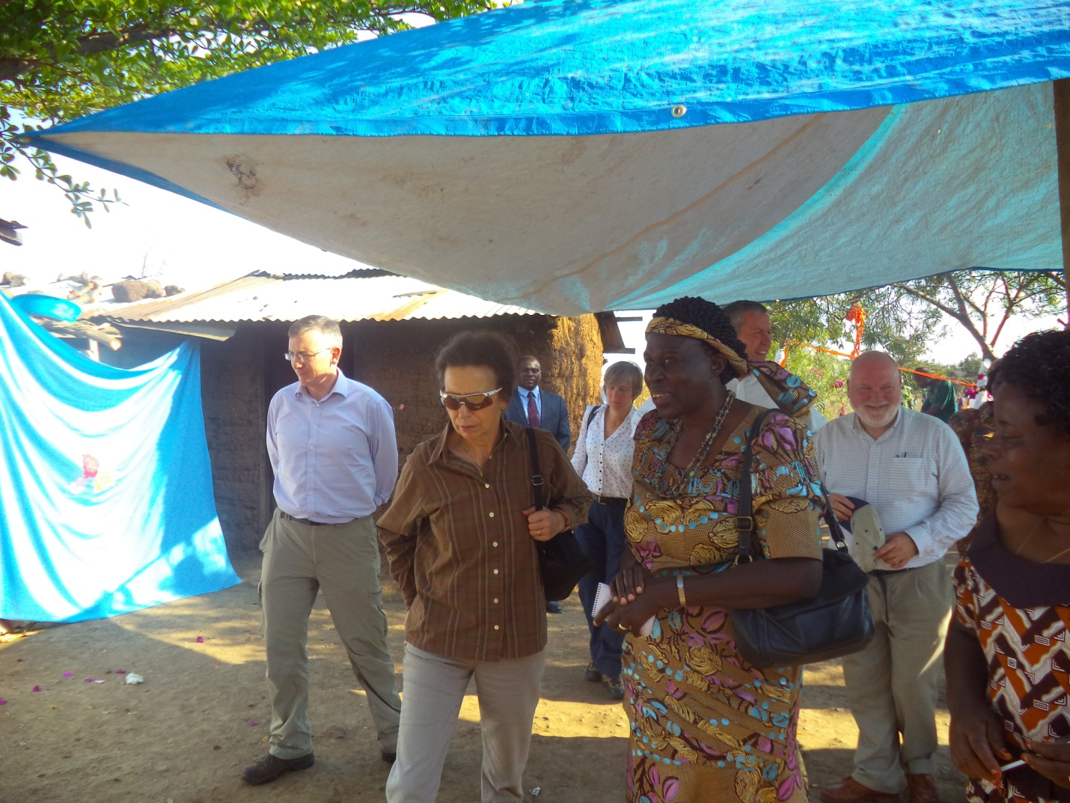
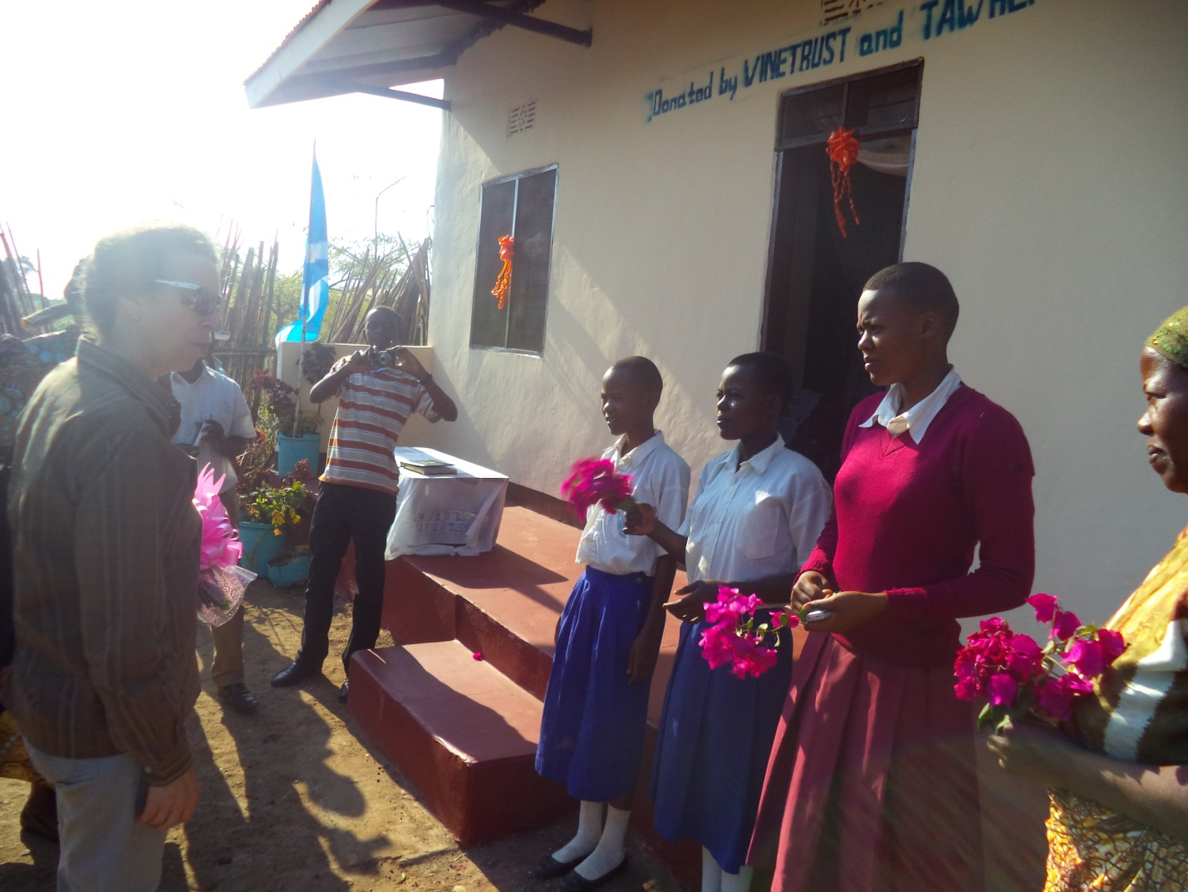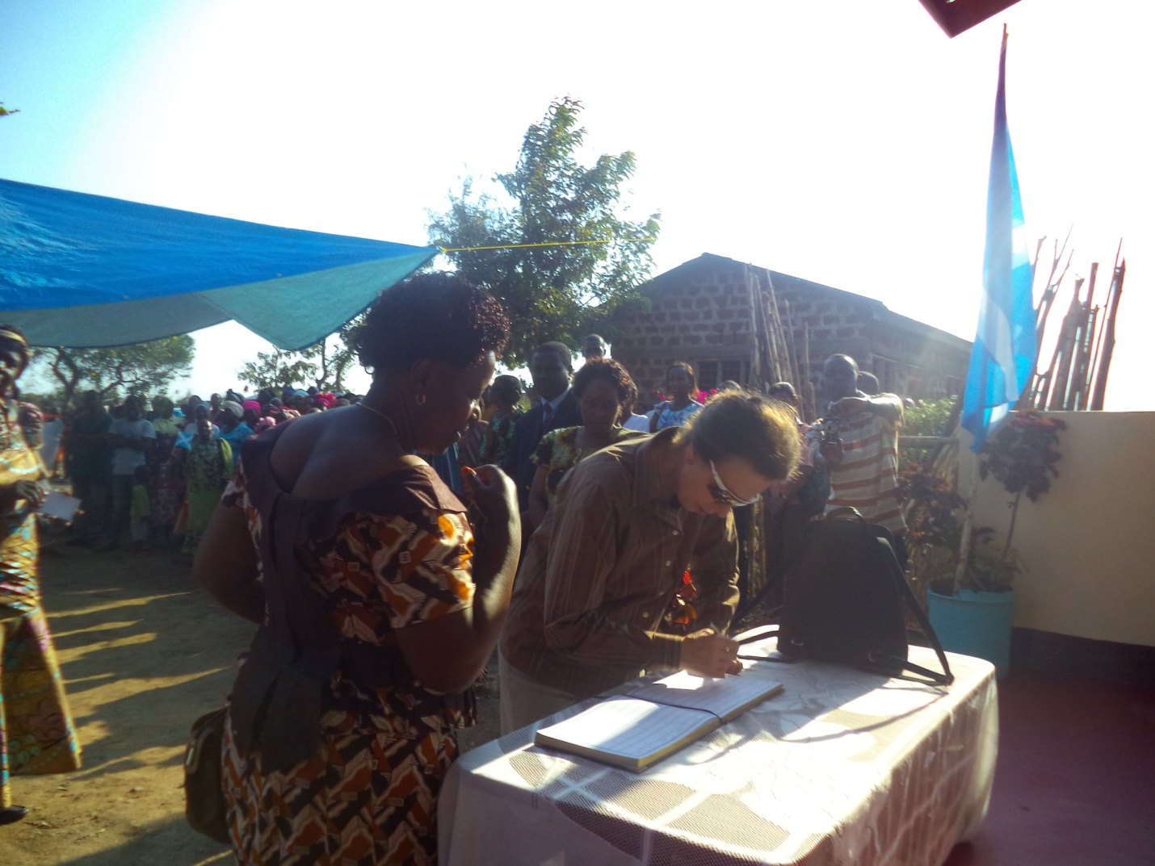

TAWREF was honoured to be visited by Her Royal Highness, Princess Ann (in dark glasses) on 2nd October 2014. The 4 pictures show the visit she made to one of the houses at Kwa Sadala constructed by Vine Trust of Scotland of which she is the Patron.

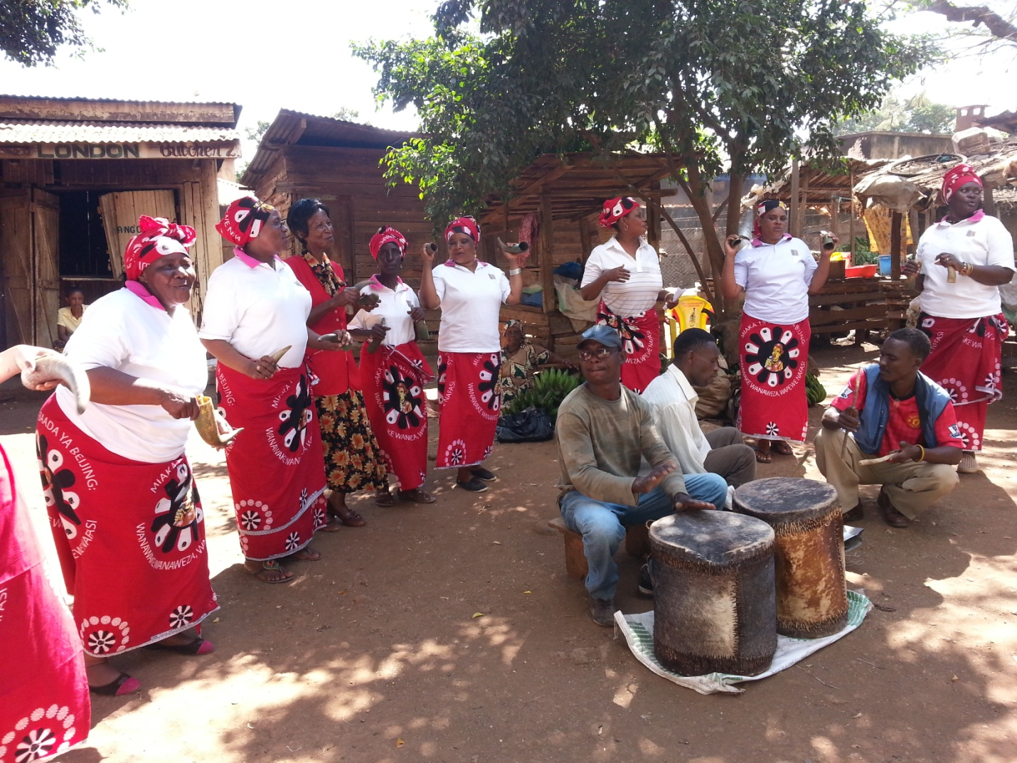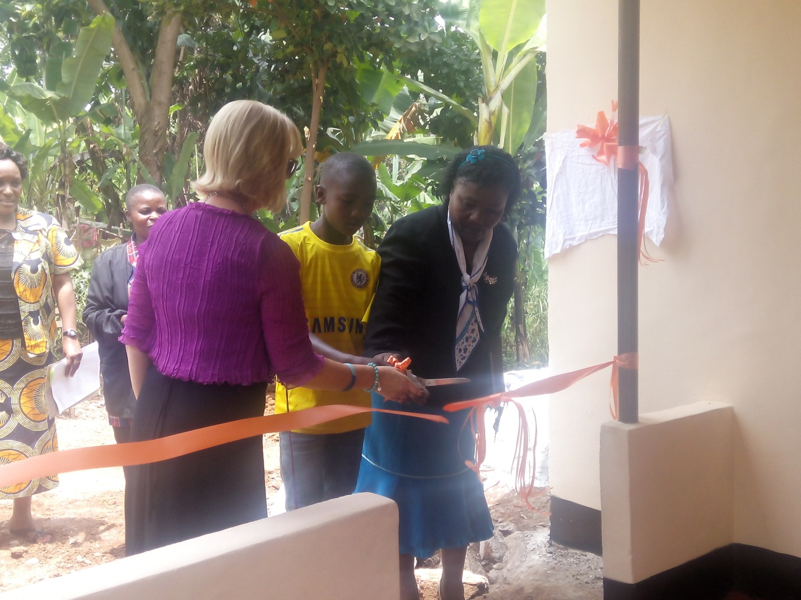
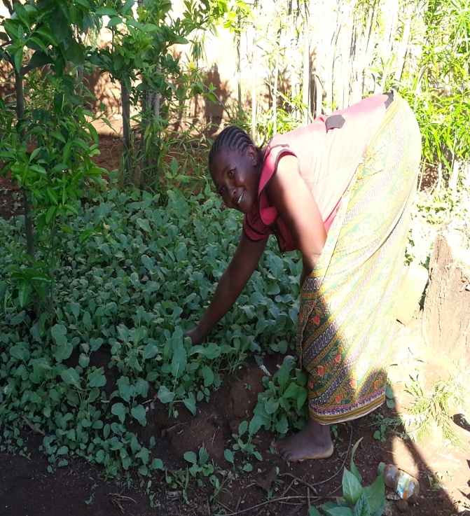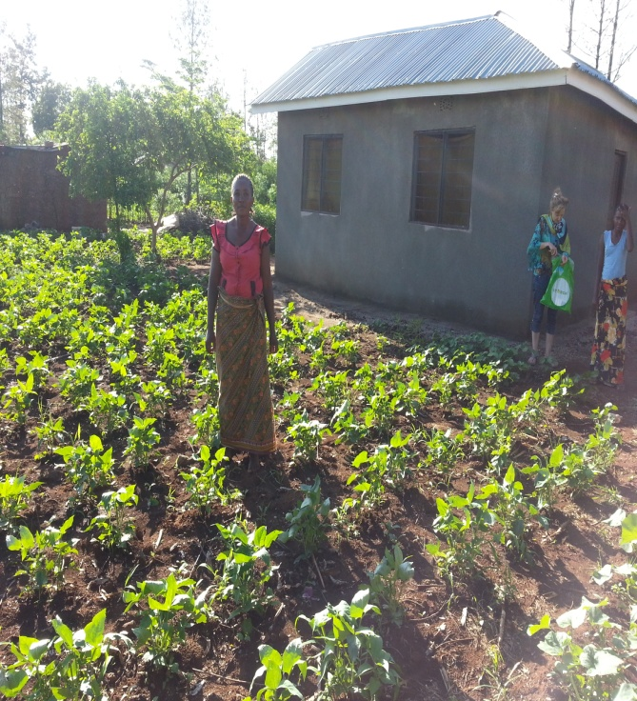
Top left: A community Theatre Group sensistizing on the values of the rights of people living with disability. Top Right: Official opening of one OVC house in Masama. Bottom: Kitchen gardens established to improve nutrition for shelter beneficiaries.

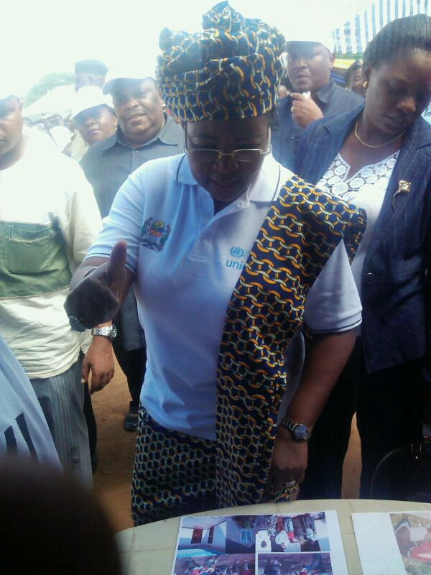

The first Lady of Tanzania, Madam Salma Kikwete gives a big up to TAWREF when she visited our exhibition at the launching of the Ant polio Campaign for girls in Moshi in April 2014.

